Data Science Report **Factors Affecting Education**



Ana Cury

13th October 2022



**Introduction**

Once Covid-19 struck, the world focused on its short-term effects on health, ignoring its impact on Education. Generation Z suffered an enormous change either leaning virtually or not learning at all due to Covid. The pandemic widened the educational opportunity gap and disrupted school systems all over the world. Schools lost teachers, teachers lost students, and students lost motivation. In this paper, the comparison of stress increased with virtual VS. physical schools, the loss of friendships and relationships, the effect of a parent's level of education on their kids, and the location of where the kid lives will all be discussed. 15 states were surveyed and their address, parents' level of education, gender, and age all have a major impact on their response to Covid-19. It is important to measure the change in education the youth has suffered due to this pandemic.

**Data & Analysis**

Once schools adjusted to Covid they responded in 3 ways: virtual, hybrid, or in-person.

Kids and teachers had never used an online platform to communicate before so it produced negative impacts on children. Kids rated their stress levels before and after Covid; Those who remained hybrid felt they experienced an increase of 1.6 stress and those who remained fully online rated on average

a 1.5 increase in stress. In contrast, students who went back to physical education surveyed a decrease of 0.3 levels of stress. On average, students in Indiana and West Virginia reported the highest levels of stress due to Covid. 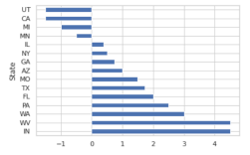

This could be due to limited access to

resources and the technology that online

school requires. Indiana also has a high

rate of teacher shortage which increased

tremendously during covid.

Increased Stress Level

1



Effect School Stress

Parents Job

The data showed that students with parents who work at home or in jobs that didn’t include health, services, or teaching, had an easier time adapting to a different learning environment.

Students whose fathers worked in the health industry felt 12% more stress than those with a dad who worked at home. With the pandemic medical assistance demand increased so these parents may not have been there to assist their children during the school day; however, at home parents relieved the stress and struggles of an online/hybrid education.

Parents' Level Of Education

As can be reasonably inferred, a 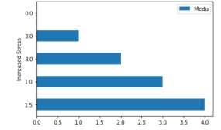

parent's level of education affects

their socioeconomic status,

contributing to the opportunities

and accessibility they can support

their children with. With 4 being a

professional/master's degree, and 1

is graduating high school, we see

the average stress a student

gained compared to their parent's

education. As predicted, the higher

Level Of Education Of Parent

education level of the parents, the more resources they have to provide their child with adjusting to Covid.

Gender & Address

The studies inferred that whether a student was female or male, and living in an urban or rural region had no impact on how the student adapted to a different learning environment. A female living in an urban setting had the same impact as a male living rurally.

2



Effect on Friends & Relationships

Due to the isolation during Covid and spending less time with school peers and friends, students suffered emotionally leading to a loss of friend relationships. Studies showed that females suffered through the loss of 33% more friends than males did. Surprisingly it also showed that students with parents who worked at home lost more friends than parents who worked in health and service careers. Since students had parents with them during the day they probably spent time with their family, while students whose parents were working had more time to maintain their friendships with school friends.

In this graph, the comparison 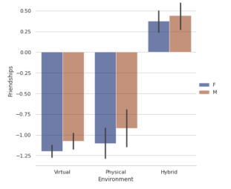

of friendships lost/gained is

shown. Students who were

hybrid experienced a positive

effect on their friendships

since they got to interact

personally with teachers and

students and also family.

Virtual students had the

greatest negative impact

since they had 0 interaction

with school acquaintances.

In-person students reported a

decrease in friendships

because they had just

switched to in-person when

this study was made so they

were accounting for losses of friendships from an

online school. 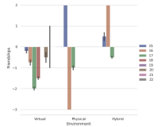

Age

The age varied greatly in their effect on friendships so

it has little effect on a student's well-being.

3



**Conclusion**

In Conclusion, the environment of a child has a great impact on its stress and friend relationships. A student's gender and address had a minimal on their stress levels. However, students who learned online or hybrid reported to have suffered a greater amount of stress than those in person. A parent's level of education and job were also factors that impacted a student's education and well-being. This is crucial information in case another Pandemic happens, so people are more prepared to provide a more adaptable environment for kids.

4